YEAR 9 SCIENCE ARANMORE CATHOLIC COLLEGE
LIFE AND LIVING PRACTICAL ASSESSMENT
DISSECTING A MAMMALIAN HEART

In this activity you will be observing, then dissecting a heart from a sheep. Follow all instructions given by your teacher and only proceed when you are sure what to do. Everyone in your group is expected to participate in some way. Every student must complete their own questions and drawings.

PROCEDURE
- Collect the heart and place it the correct way up on your dissecting tray. Identify the outside structures of the heart with everyone in your group. Use the diagram below to help you.
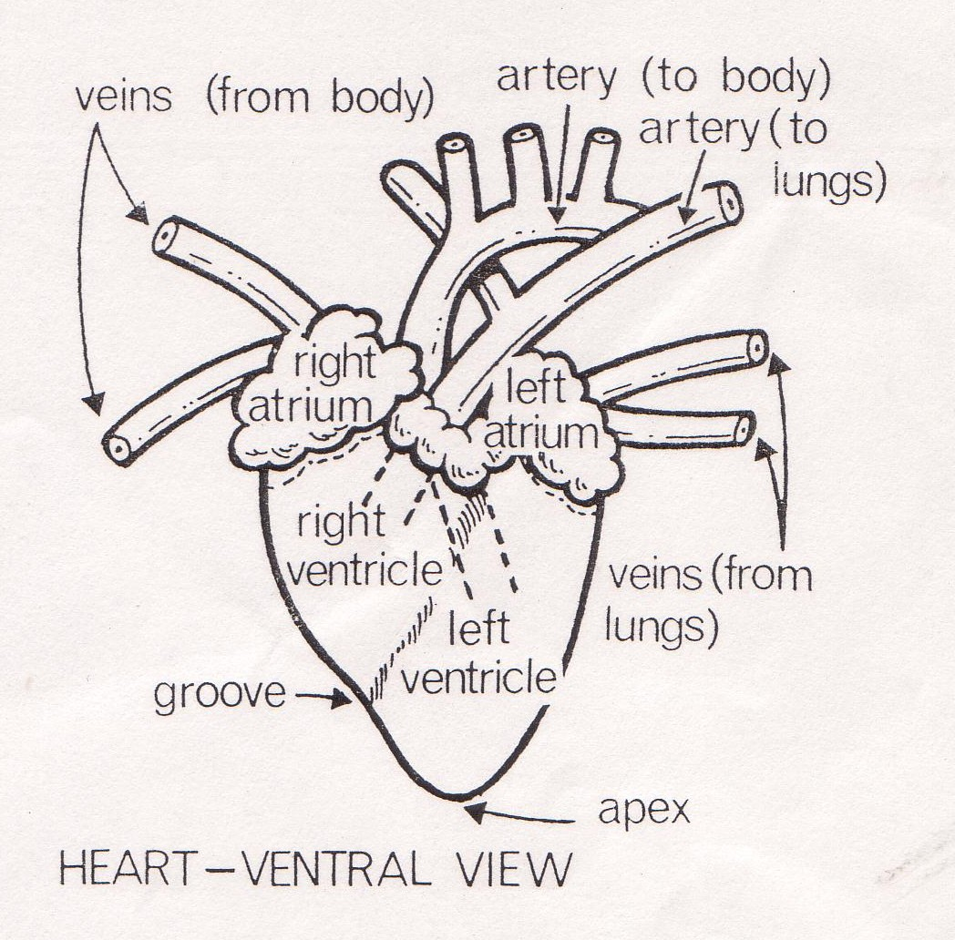
Complete this checklist of parts by ticking each structure as you identify it.

a) apex (pointed end)
b) left ventricle
c) right ventricle
d) left atrium
e) right atrium
f) any arteries
g) any veins
h) coronary arteries
(on the surface of the muscle)

2) Describe the texture, colour and appearance of the muscle surrounding the two ventricles. (2 marks)

3) How does this muscle differ from the muscle surrounding the atria (left and right atrium)? (2 marks)

4) Explain why you think the muscle surrounding the ventricle and atria are so different. (2 marks)

SHOW YOU WORK TO YOUR TEACHER BEFORE CONTINUING TO THE NEXT SECTION

- DISSECTING THE HEART. Using a scalpel, CAREFULLY cut a 2cm cross section across the apex of the heart. Cut all the way through by gently pressing on the tissue, retracing the same line over and over.
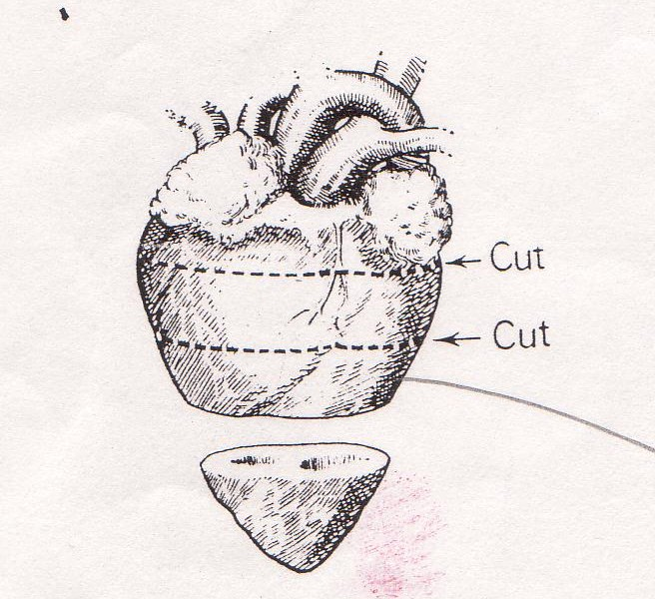
- Cut a further two more sections across the
heart. Arrange the slices in the correct order
on your dissecting tray. They should all fit back
together to form the complete heart again.
KEEP THE SLICES IN THE CORRECT ORDER

7) Place the third slice flat on your tray. Work out which side is the left and right ventricle. Draw the section showing the space for the blood, the ventricle wall and the cardiac muscle. Clearly label your drawing.
8)Is the cardiac muscle thickest surrounding the left ventricle or the right ventricle?
__________________________

9)Using your knowledge of the heart and circulatory system, can you explain why muscle is thicker on one side than the other?
_______________________________
_______________________________
_______________________________
_______________________________
LL4BCD
/ 5
CLEAN UP YOUR AREA AND RETURN YOUR EQUIPMENT AS INSTRUCTED
10) Control of Heart Rate.
Sometimes your body need to change the rate at which the heart works in order to perform an important process or to protect itself. It achieves this control in several ways. Read the following scenario, then describe how the body’s control systems would respond and what immediate effects it would have on the heart. Explain why this occurs.
“You are walking down a dark road at night. In the trees you see shining eyes and hear strange rustling sounds. Suddenly, something leaps from the shadows and runs straight at you……….”
END OF ASSESSMENT

